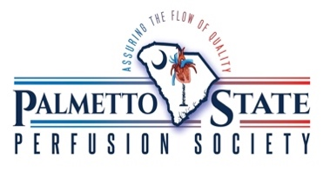
2023 Carolina Perfusion Symposium
Abstract Submission Form

Thank you very much for your interest in presenting at the Carolina Perfusion Symposium!
To be considered for speaking, please submit the following:

Name:
Institution or Affiliation:
Student or CCP:
Type of submission:
(Oral Presentation, Poster, or both)
Professional contact email:
(This email will be posted on the meeting agenda)
Abstract:
(300 words or less)

Individuals with proposals chosen for inclusion in the 2023 Carolina Perfusion Symposium will be notified promptly!

Please submit all submission forms to: PalmettoPerfusion@gmail.com
Any questions, please contact Ken Ingersoll: Ken@PerfusionLife.com

